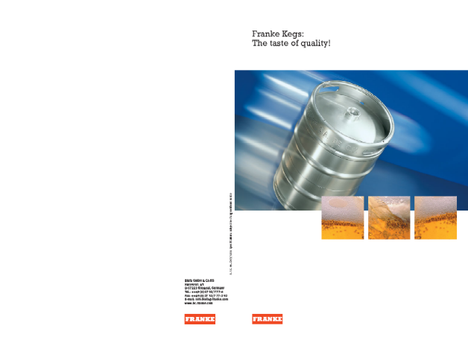
Keg Manufacturing Process

Author: Nick LaRocca
11/10/07
MEEG 453/653
Summary: Kegs have been around for centuries. Although their purpose is simple, the manufacturing of these have evolved greatly over the years. They have gone from wood with steel hoops to stainless steel. Through this path they have decreased in weight and cost while increasing durability and protection from the environment. The modern process of deep drawing the keg and then welding the halves together is outlined in my paper.
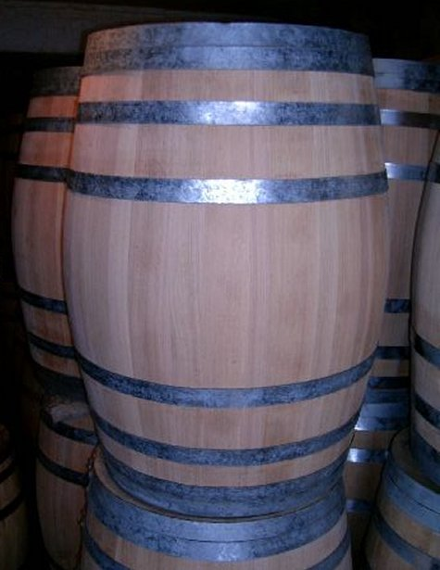
Brief History
The keg has been around for centuries. Wooden barrels were introduced in medieval times as a means of transporting beer. Back then, kegs were made out of wood bound by steel hoops. This was used up until the second half of the 20th century. A manufacturing method that was introduced in the 1950’s uses stainless steel instead. In the next decade, aluminum alloys were also utilized as well as stainless steel. Both these metals were used for their high strength and corrosion resistance. This process used consisted of 5 components that pressed into shaped and then welded together. This was the primary method used up until the late 80’s when a deep-drawing technique was developed for keg manufacturing. In this assignment, I will be discussing both these processes.
Materials
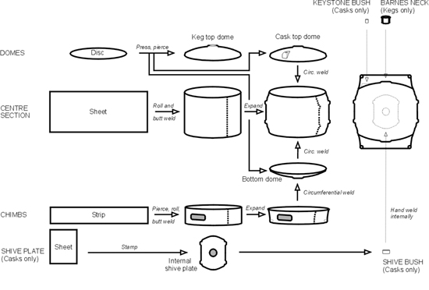
Kegs must be corrosion resistant to beer, strong enough to withstand handling, and volumetrically stable during internal pressure caused by the carbon dioxide inside. They have an expected lifespan of 10 years as well. As mentioned before, stainless steel is the most prevalent material used in keg manufacturing. They are extremely corrosion resistant and current manufacturing processes give it extremely high strength. Aluminum alloys were also introduced because of their light-weight. Before drawing was used to manufacture kegs stainless steel kegs had to be very thick to get the required strength and made aluminum a great alternative. Being light-weight is very important because kegs are handled frequently. Beer has a pH that can be less than 4. This is low enough for the acid to eat away at the oxide layer on aluminum alloys, but stainless steel can withstand this. For this reason aluminum kegs are internally steam sealed, anodized and coated in an epoxy lacquer. They also need to be baked at 190 C to cure the epoxy. Stainless steel only needs to be treated with 3% hydrofluoric/10% nitric acid to de-scale the welds.
Forming and Drawing
Welding and Forming Process
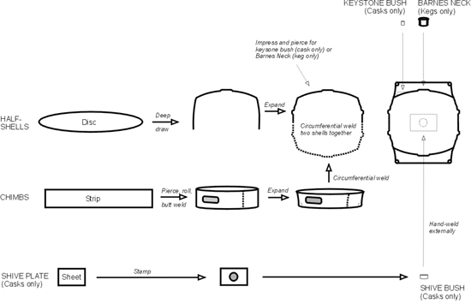
The traditional form of manufacturing kegs involves 5 components that are then welded together. These consist of a keg top and bottom dome, center section, chimbs on the top and bottom. The top and bottom domes are press formed and the center is rolled and butt welded. The chimbs are also rolled and butt welded. All these components have to be welded together which is a labor intensive process. This process did not give good strength properties either so the walls have to be thicker which requires more material. For these reasons, this process has been decreasingly used to manufacture kegs over the past 20 years.
Deep Drawing Process
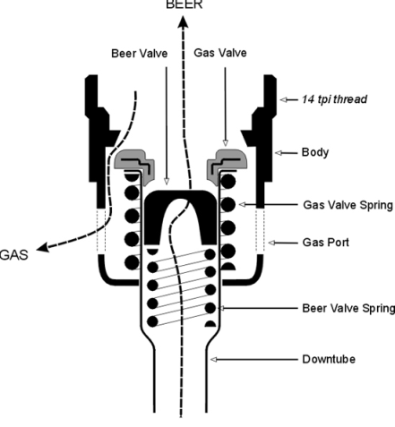
The preferred method of manufacturing is deep drawing two blanks of either stainless steel or aluminum alloy into two halves of the keg. Deep drawing the keg gives the keg excellent strength from the cold-working of the metal during the process. The chimbs on the top and bottom of the keg are manufacturing starting with a strip of sheet metal that is rolled into a ring and butt welded. Two oval patterns are cut out of the top chimb to make handles. If you have ever tried to move a keg, you will know why these are necessary. These 4 components are welded together with only 3 circumferential welds.
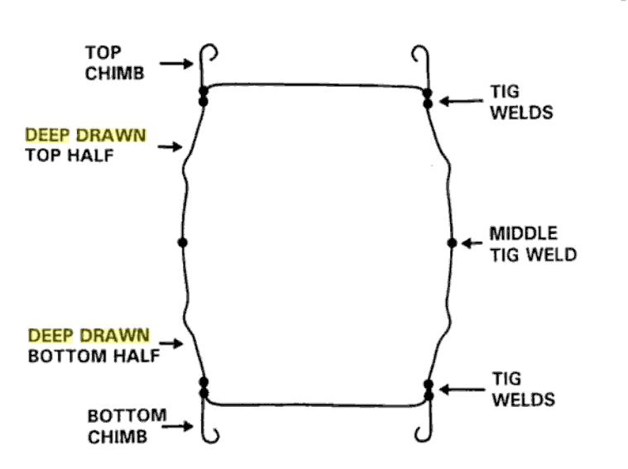
Next the extractor and racker are installed. This consists of a valve that is spring loaded. Gas is pumped into the keg and beer is pushed up the extractor through a tube that leads to the bottom.
Assembly
The aluminum alloy kegs are welded using Metal Inert Gas (MIG) welding which uses a filler wire. The stainless steel kegs are welded using Tungsten Inert Gas (TIG) welding. There are several things that need to be controlled during welding. The alignment of the components is especially important on butt welds. Weld penetration has to be monitored for crevices which can cause a hygiene hazard. The porosity is important to the strength of the keg and needs to be monitored as well. After manufacture, all kegs are pressure tested to 90 psig hydraulically. They are also leak-tested by being immersed in water and filled with air at 40 psig.
Filling
During filling kegs are turned upside down and beer is injected through the washer/racker at the top of the keg. Beer is injected while air is pushed out through the tube that runs through the middle of the keg. This allows for fast, low turbulence filling.
Economics
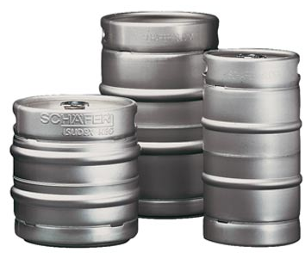
The deep drawing technique produces half-barrel sized kegs at a cost of approximately $60. The old process produced kegs that cost more than twice that. That just shows the importance of manufacturing in terms of cost of a product. They both produce the same thing, but since deep drawing has fewer steps and parts to assemble, it costs significantly less. Aluminum alloy kegs are more expensive due to the higher operating costs associated with heat treating the coatings that are required for them. The labor intensive process that used 5 components which are welded together costs more than twice the deep drawing process used today and is not as strong.
Relevance
The major significance of this topic for a beginning engineer is learning the vast number of possibilities for materials and manufacturing that are available for even simple products. The major significance for a more mature engineer is understanding that just because a process has been used for decades does not mean that it’s the best, but others can exist that can even cut your costs in half.
Learning
I learned the significance of manufacturing process in determining strength in a material such as work-hardening during deep drawing. It helped me realize the importance of not just how the part is shaped, but how it is made into that shape can greatly affect material properties.

Works Cited
Partington, Eric. “Beer Barrels from Roman Times to the Present Day” Encyclopedia of food science and nutrition. http://www.nickelinstitute.org/index.cfm/ci_id/12606.htm
Talbot, James. “Corrosion Science and Technology.” Pg. 360-361. http://books.google.com/books?id=lwLer72nHR0C&pg=PA361&lpg=PA361&dq=deep+drawn+keg&source=web&ots=7n_81pqqlE&sig=L0zWrqFvKc0WmZDKKUfqXb-vjb4#PPA362,M1
Franke Kegs Company Website. http://www.bc.franke.com/pdf/Kegs_GB_Internet.pdf

